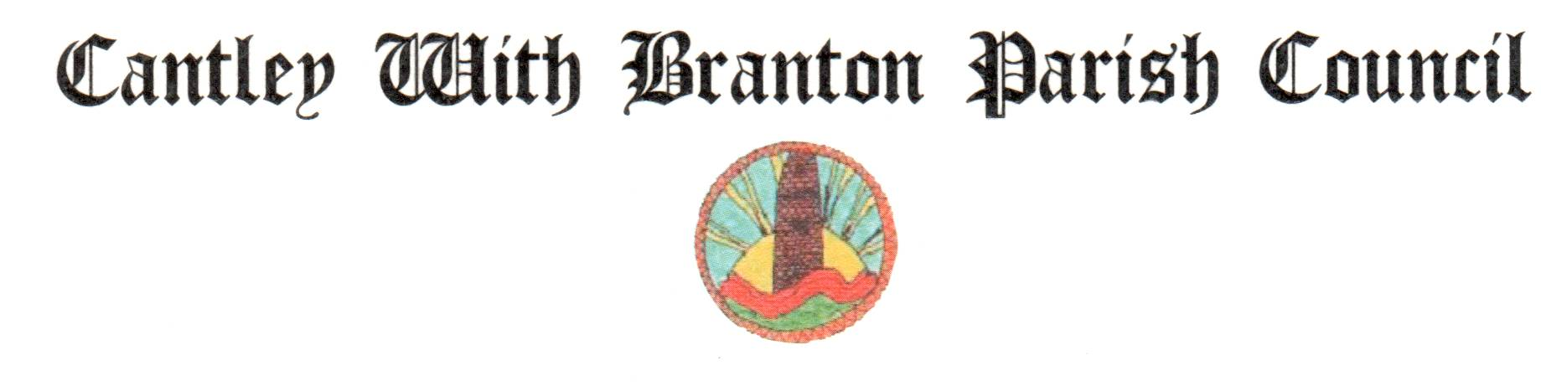
www.cantleywithbrantonparish.co.uk

Spring 2020 Newsletter

Parish Councillor Vacancy
The parish council is pleased to have co-opted Alicia Whittaker to the recently created vacancy until the next election takes place in May 2021 and would like to thank the six applicants for the interest shown. Contact details for all members of the parish council can be found on the parish council website.

Traffic Concerns on Whiphill Top Lane, Branton
A small group of residents from the Whiphill Top Lane attended the February 2020 parish council meeting to express their continuing concerns over speeding traffic and the safety of pedestrians particularly around the fork junction area on Whiphill Top Lane. In order to try and secure some improvements the parish council has arranged for the attendance of the Finningley Ward Councillors at the parish council meeting on Wednesday 4 March 2020 to discuss the concern of residents.

Keep Branton Tidy – Litter Pick on 7 March 2020
Arrangements have been made for the next quarterly litter pick to take place on Saturday 7 March 2020 and anyone wishing to take part is asked to meet at Kilham Hall Meeting Rooms at 9.30 a.m. Tea and coffee will be available prior to the commencement of the litter pick.

Next Police ‘Drop In’ Session – Monday 30 March 2020 at 6.00 pm
The next police drop in at Kilham Hall Meeting Rooms will take place on the above date. If anyone has any concerns that are police matters please come along and discuss these.

2020 Annual Parish Meeting on Wednesday 1 April 2020 at 6.30pm
To find out more about the latest developments taking place in the parish any elector can attend the meeting to raise any matters for consideration by the parish council. The April parish council meeting will follow the Annual Parish Meeting.

2020/21 Precept – Annual Review from 1 April 2020
The parish council determined that the 2020/21 precept should increase by an average of only 0.36 % (for a Band ‘D’ property) in spite of a loss of the £408 grant provided by DMBC last year. Due to an increase in the number of properties etc in the parish the total amount raised will increase to £41k an increase of £1k on the previous year to cover inflation.

The parish council would like to wish everyone a very happy Easter

